Alex Pitts

CS 362: 8 am T/R

3/4/2021

In class assignment

Link to GitHub files: <https://github.com/alexgpitts/CS362-In-Class-Assignment-pytest--unittest-and-coverage-2>

First, I started by running coverage. 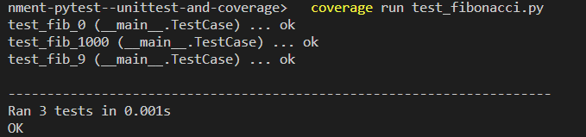

Then I used coverages report command to display the report 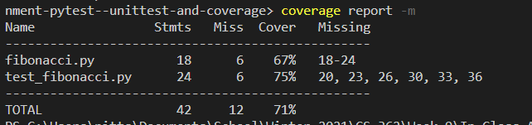

Nest I fixed by tests because coverage was not running them all. I had them all set up like pytest, when I needed them in my unittest class.

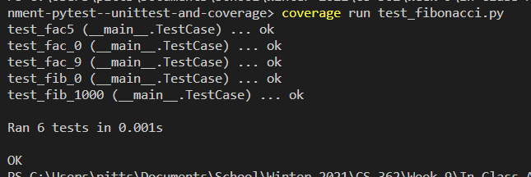

Now, when I ran the report command again, it showed all my test.

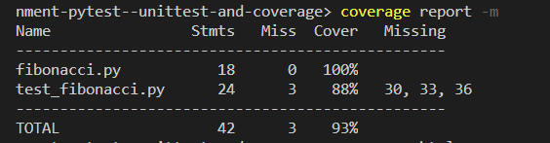

Next, I ran the html command to generate an html page report



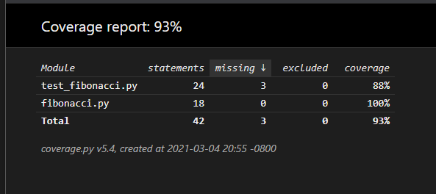

Next, I ran pytests coverage test on my file.

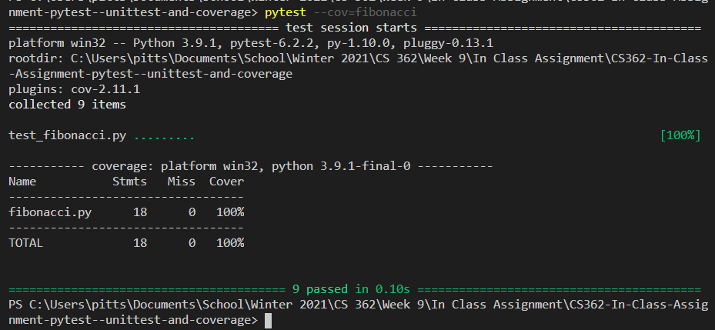

Finally, I ran the html command for the pytest coverage test which generated an html report. It did overwrite my old one for some reason.

